Barlow House Surgery

Patient NHS Experience Survey 2025/2026

What we did
Reception handed out paper copies or directed patients to use the QR code from 30th July 2025 -31 January 2026
QR code and weblink were shared on our social media, website, and on posters
Patients who attended were also sent a text message at the end of each week with a link

Responses
A total of 233 surveys were completed: 83 online, 150 on paper.

The paper copy was bilingual, and the online version could be completed in Welsh or English.
0 copies had comments in Welsh written in them. 0 Welsh versions of the online survey were completed.

This document includes a breakdown of the responses
A small selection of the comments, Practice Response / Action plan

What next
Edited version of this will be made available to patients during November 2024 and Reflective document submitted to Health Board C WAG by end March 2024 as required under the GMS Contract

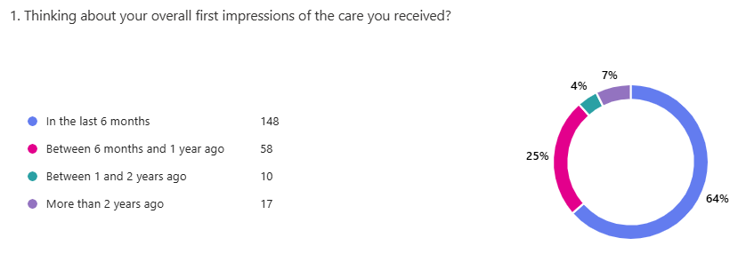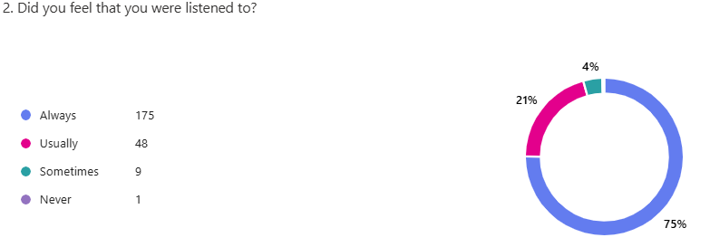

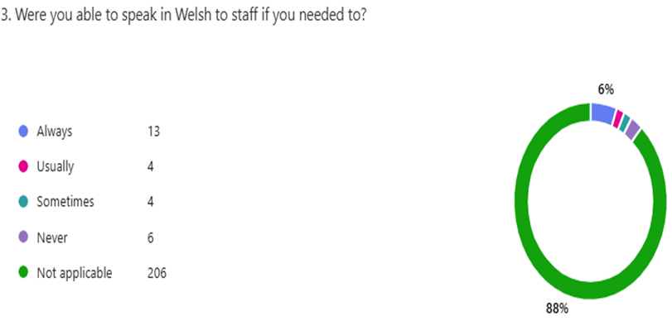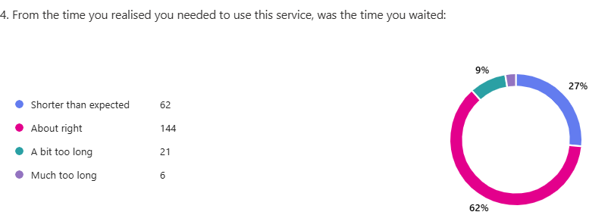

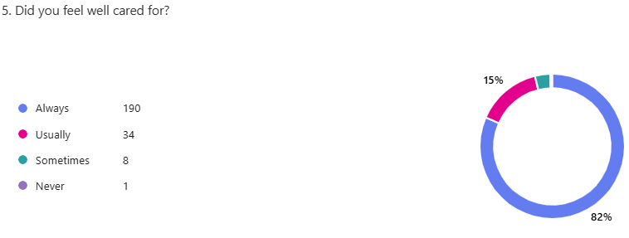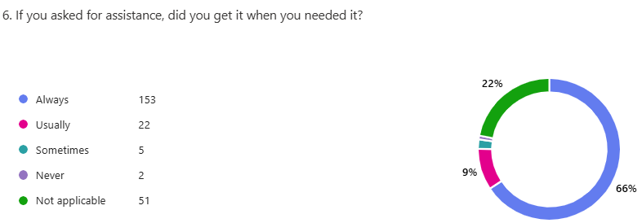

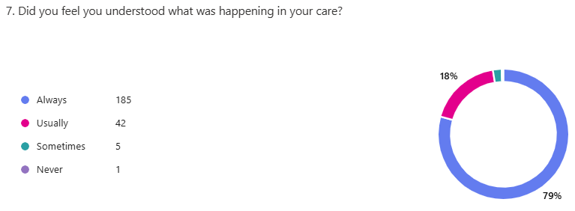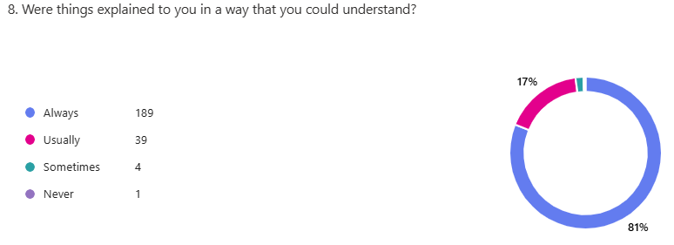

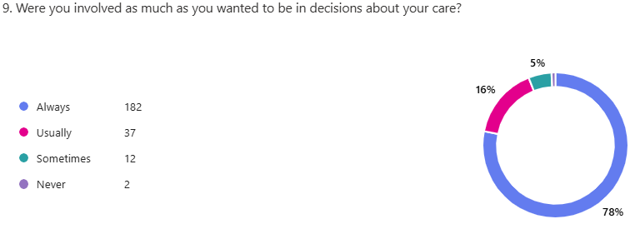

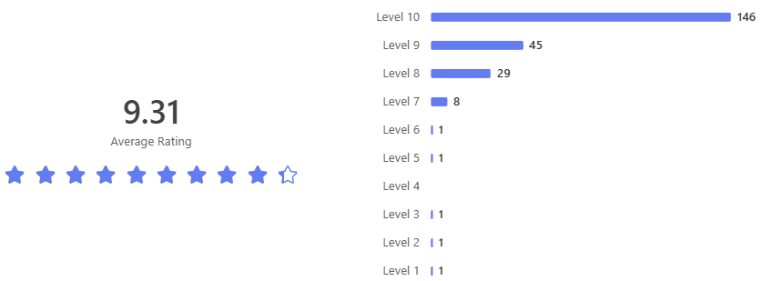

Demographics of patients completing the Survey

Ages of responding patients
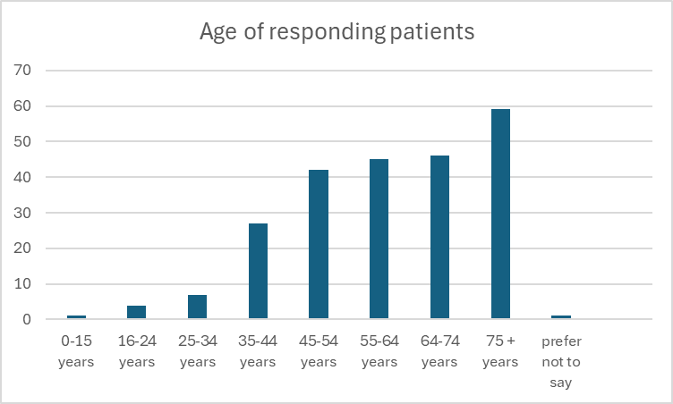
Gender 60% of survey respondents gave their gender as female, with 39 % saying male.

Gender at birth 60% female, 39% male.

Which of the following options best describes how you think of yourself?
Heterosexual or straight 95%, Gay or Lesbian 3%, “Other” 1%, 1% “ I prefer not to say”.

Are your day-to-day activities limited because of a health problem or disability which has lasted, or is expected to last, at least 12 months?
42% answered “not at all”, 27% said a little, 29% said “Yes a lot”, 2% preferred not to say.

Ethnicity
57% Welsh, 25% English, and 17% British, and 1% Irish.

Religion
64% Identified as Christian (All denominations), 33% stated they had no religion,
. The remaining percentage included Buddhist, Jewish, “another religion” and “prefer not to say.

Was there anything particularly good about your experience that you would like to tell us about

Spotlight on Receptionists
Receptionists are great.

Excellent communication from the receptionists and always working hard to sort any
issues promptly.

Receptionists are amazing in Barlow House Surgery
Reception staff are very welcoming and helpful.

Receptionist very polite and accommodating
The reception staff are always kind and empathetic, which is rare with GP Practices
The receptionists are always polite and make an effort to accommodate your wishes.

Reception staff are always friendly & helpful.

Never really any problem getting an appointment The staff are amazing
Staff are always Polite & Courteous The Staff are polite and remain helpful when under pressure

Spotlight on the
Clinical Team

Doctor was very helpful and it felt like she really cared, which is rare!

Doctors & nurses always explain things in detail and go the extra mile to give help and advice

From start to finish everything was explained with the lack of doctors jargon.
Dr. Yelland's knowledge and care with regard to women's health has been exceptional.
Dr Marshall is a very good Doctor! He listened to me and helped me get diagnosed after 5 years.

Dr Cohen is Brilliant
Dr Davies was very good listener and able to make thorough examinations. Very happy with my care

Staff and Nurses are brilliant. I always get polite, professional service from the telephone and reception staff, as well as doctors, of course. Do what you are doing you are fab!
Practice-wide, complimentary comments

Great experience with this surgery

Service, staff, and treatment are always first class

Access to GP appointments was excellent, thank you. Dr. Yelland was amazing

I would recommend this surgery

I have never had any issues with Barlow House. I always use the app to make my appointments

Fantastic service from start to finish.

I was very fortunate, up until recently, to rarely need to see a GP. From appointment making, help from Receptionists, and of course the GPs that I have seen, the care that I have received has been very good. That the Pharmacy is attached to the building is also a bonus
Was there anything that we could change to improve your experience
Lots of patients commented “no” or “nothing” in this section … here are a few of the other comments

Far too much introductory information in the phone message. It takes ages to get through it all and is unnecessary. Making it easier to get hold of doctors without having to spend ages on the phone before you get to speak to someone in person.
It would be nice if I could see the GP on time. A different phone line to cancel appointments as the wait is too long, which would prevent people from not turning up for appts.



Waiting for appointments is too long.

It would be nice to have the same doctor all the time.

I would like to be able to see the same doctor each time when going back for a reassessment of my condition.

Option to send photos of the ailment so you do not have to attend surgery.

Practice Response to Patients
The results of the survey and all comments have been shared with the Practice Team.
The Practice Partners have provided constructive feedback in response to the results.
- Thank you to all patients who took the time to complete the NHS Experience Survey and gave feedback on the services they have received.
- The welcome message on the telephone uses mandatory wording provided by the Welsh Assembly Government as a requirement of the General Medical Services Contract. The information provided is important.
- The Practice currently has a two-week wait for routine appointments, which is not considered unreasonable.
- The Practice is actively reviewing the feasibility of introducing a dedicated line for appointment cancellations.
- GPs request photographs only when a patient is unable to attend the surgery and when it is clinically necessary. It would not be considered safe practice to make a diagnosis based solely on a photograph, particularly if the image quality is poor.
- Patients are able to see the same GP; however, waiting times for a specific GP may be longer.

